Paul Leonardo Grippa Vento and Sean William Meath

Raw Table data (Cards table)
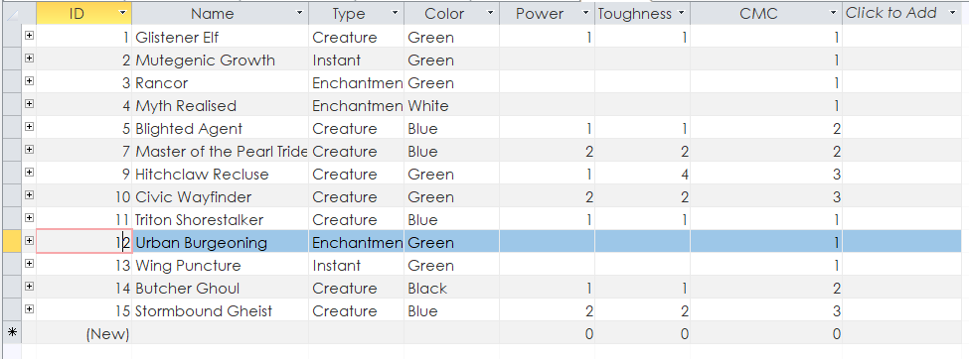
All our queries predict events in this table

Predict 1:
Probability that he is green and the Toughness is 1
Using Bayes theorem we split the query into 2 separate queries that we multiply;
These 2 queries are:
Probability that the card is green:
We got this by dividing the amount of green cards by the total amount of cards

Probability that the toughness is 1 given the card is green:
We got this by dividing the amount of cards that are green and having a toughness of 1 by the total amount of green cards.

SQL:
SELECT [exp1]*[exp2] AS Expr1
FROM [P(Green Card)], [P(Toughness = 1 && Color = Green)];
Result:


Predict 2:
Probability that he is green and the Power is 1
Using Bayes theorem we split the query into 2 separate queries that we multiply;
These 2 queries are:
Probability that the card is green:
We got this by dividing the amount of green cards by the total amount of cards

Probability that the Power is 1 given the card is green:
We got this by dividing the amount of cards that are green and having a Power of 1 by the total amount of green cards.
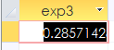
SQL:
SELECT [exp2]*[exp3] AS Expr1
FROM [P(Green Card)], [P(Power = 1 && Color = Green)];
Result:

Predict 3:
Probability that he is green and the CMC is 1
Using Bayes theorem we split the query into 2 separate queries that we multiply;
These 2 queries are:
Probability that the card is green:
We got this by dividing the amount of green cards by the total amount of cards

Probability that the CMC is 1 given the card is green:
We got this by dividing the amount of cards that are green and having a CMC of 1 by the total amount of green cards.

SQL:
SELECT [exp2]*[exp4] AS Expr1
FROM [P(Green Card)], [P(CMC = 1 && Color = Green)];
Result

Predict 4:
Probability that he is green and the Type is a Creature
Using Bayes theorem we split the query into 2 separate queries that we multiply;
These 2 queries are:
Probability that the card is green:
We got this by dividing the amount of green cards by the total amount of cards

Probability that the Type is a Creature given the card is green:
We got this by dividing the amount of cards that are green and having a Type is a Creature by the total amount of green cards.

SQL:
SELECT [exp2]*[exp5] AS Expr1
FROM [P(Green Card)], [P(Type = Creature && Color = Green)];
Result

Predict 5:
Probability that he is green and the Toughness is 1 and the Power is 1
Using Bayes theorem we split the query into 3 separate queries that we multiply;
These 3 queries are:
Probability that the card is green:
We got this by dividing the amount of green cards by the total amount of cards

Probability that the toughness is 1 given the card is green:
We got this by dividing the amount of cards that are green and having a toughness of 1 by the total amount of green cards.

Probability that the Power is 1 given the card is green:
We got this by dividing the amount of cards that are green and having a Power of 1 by the total amount of green cards.

SQL:
SELECT [exp1]*[exp2]*[exp3] AS Expr1
FROM [P(Green Card)], [P(Power = 1 && Color = Green)], [P(Toughness = 1 && Color = Green)];
Result:


Predict 6:
Probability that he is green and the Type is Creature and the Power is 1
Using Bayes theorem we split the query into 3 separate queries that we multiply;
These 3 queries are:
Probability that the card is green:
We got this by dividing the amount of green cards by the total amount of cards

Probability that the Type is Creature given the card is green:
We got this by dividing the amount of cards that are green and having a toughness of 1 by the total amount of green cards.

Probability that the Power is 1 given the card is green:
We got this by dividing the amount of cards that are green and having a Power of 1 by the total amount of green cards.

SQL:
SELECT [exp2]*[exp3]*[exp5] AS Expr1
FROM [P(Green Card)], [P(Power = 1 && Color = Green)], [P(Type = Creature && Color = Green)];
Result:


